Promoting SMART agricultural WATER management
in Bosnia and Herzegovina - SMARTWATER

The 2nd Summer School

Smart technologies and best management practices (technical and practical) for sustainable and eco-efficient agricultural water management

- Programme –

Sarajevo, Bosnia and Herzegovina
July 18 - 22, 2022
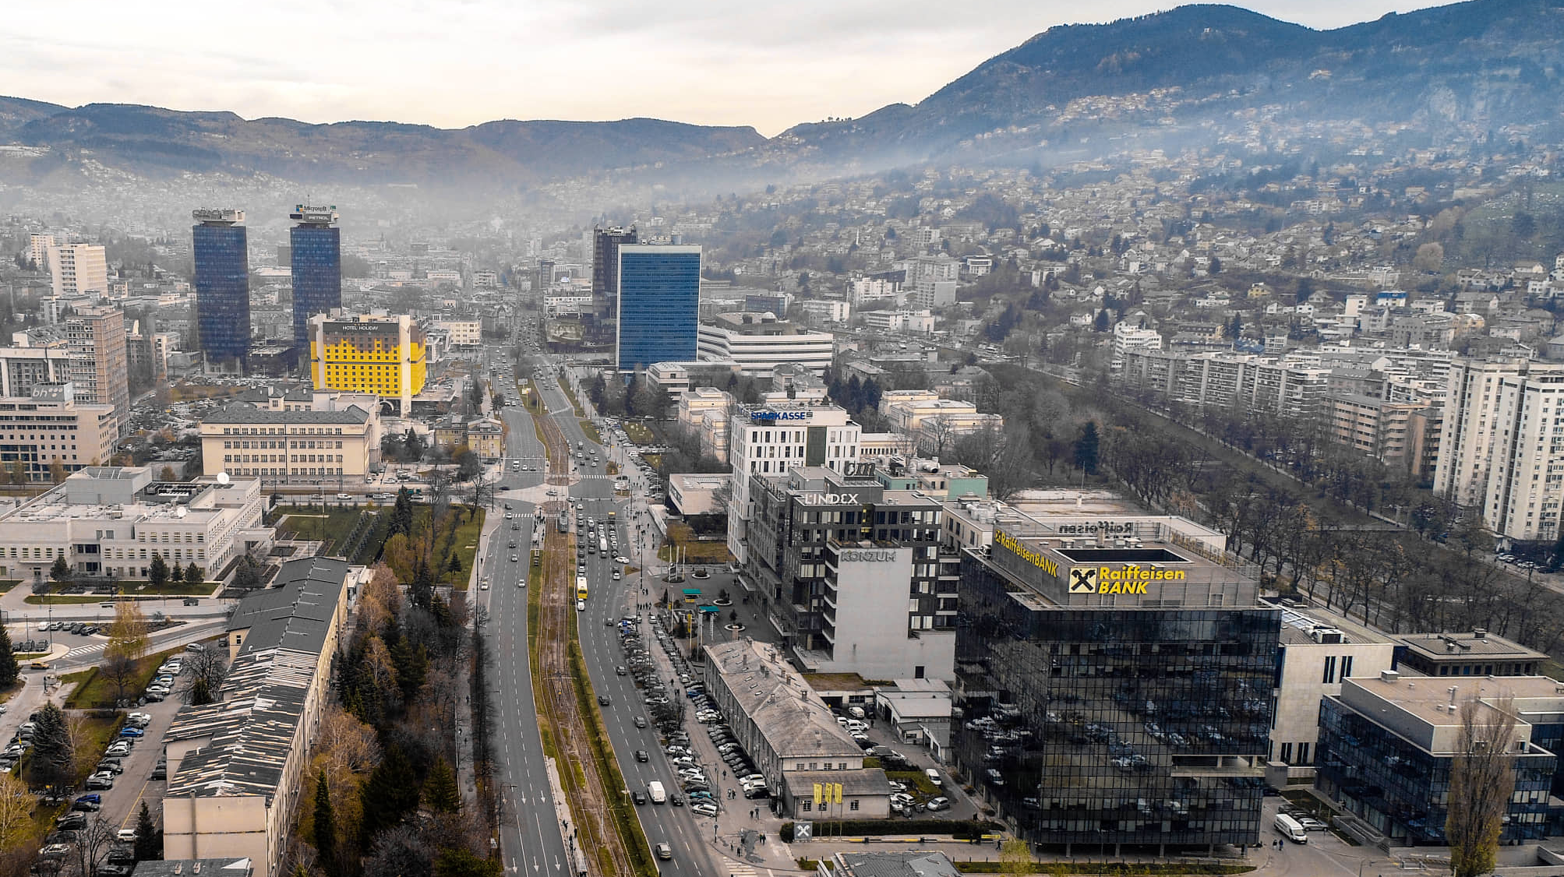

PROGRAMME

Monday, July 18, 2022
Faculty of Agriculture and Food Science, University of Sarajevo (UNSA)
(Zmaja od Bosne 8, 71 000 Sarajevo, BiH)

CET | TOPIC | LECTURER(S)
9:00 - 9:30 | Registration  - UNSA - | All
9:30 – 10:00 | WELCOME SPEECHES  Representatives of the University of Sarajevo (UNSA);  SMARTWATER project coordinator (UNI-BL)
10:00 - 10:30 | Project implementation  - status and perspectives - | Sabrija Čadro  UNSA
10:30 - 11:30 | Eco-efficient agricultural water management: concept and application | Mladen Todorović  CIHEAM-BARI
11:30 - 12:30 | Coffee break | All
12:30 - 13:30 | Coupling smart technologies and best management practices in agricultural water management | Mladen Todorović  CIHEAM-BARI
13:30 - 14:30 | Adoption of DSS for agricultural water management, Blueleaf DSS – technical overview | Luigi Capodieci  SYSMAN
14:30 - 15:30 | Blueleaf interactive session with real use case of application | Luigi Capodieci  SYSMAN
15:30 - 16:30 | Lunch break | -

Tuesday, July 19, 2022
Faculty of Agriculture and Food Science, University of Sarajevo (UNSA)
(Zmaja od Bosne 8, 71 000 Sarajevo, BiH)

CET | TOPIC | LECTURER(S)
09:00 - 10:00 | Implementation of River Basin Management Plans in Spain, the Ebro River Basin as a study case. | Marian Lorenzo  CSIC
10:00 - 11:00 | Low-pressure sprinkler irrigation in maize | Enrique Playán  CSIC
11:00 - 12:00 | Irrigation governance in developing countries: problems and solutions | Enrique Playán  CSIC
12:00 - 12:30 | Coffee break | -
12:30 – 13:30 | Network to control water quantity and quality of irrigation return flows | Marian Lorenzo  CSIC
13:30 - 14:30 | Lunch break | -
14:30 - 16:00 | Preparation and flight planning of unmanned aerial vehicles (UAV) | Sabrija Čadro  UNSA

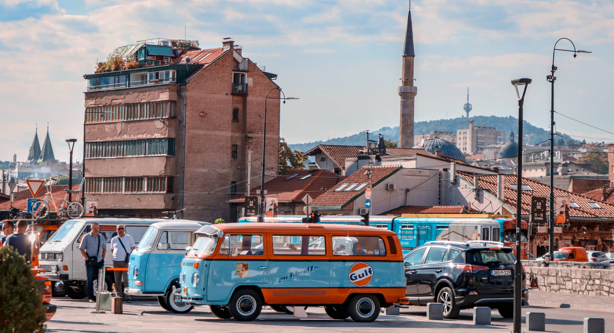

Wednesday, July 20, 2022
Field visit to Visoko, BiH

CET | TOPIC | LECTURER(S)
09:00 - 13:00 | Visit to an agricultural  producer in Visoko;  Use of unmanned aerial vehicles (UAV) for surveying agricultural land -  field exercises | Sabrija Čadro  UNSA
13:00 - 15:00 | - Touristic tour of Visoko pyramids - | All
15:00 - 18:00 | Lunch break | All
18:00 - 19:00 | Return to Sarajevo and free time | All

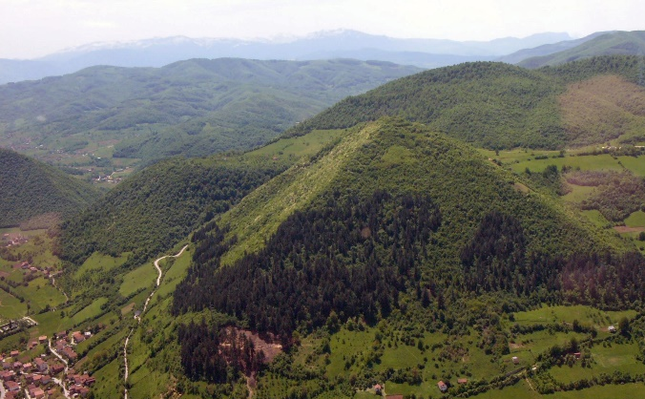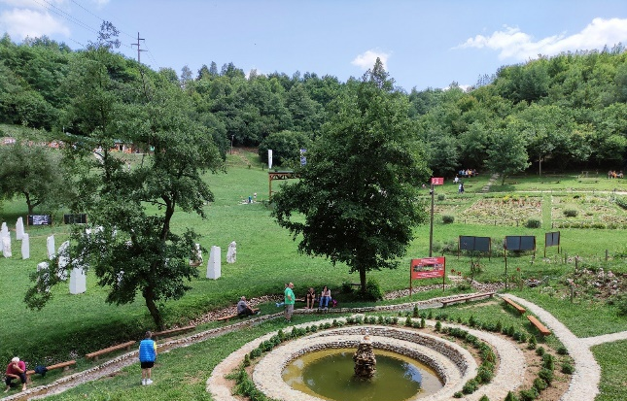

Bosnian Pyramid of the Sun and Park Ravne
Thursday, July 21, 2022
Faculty of Agriculture and Food Science, University of Sarajevo (UNSA)
(Zmaja od Bosne 8, 71 000 Sarajevo, BiH)

CET | TOPIC | LECTURER(S)
09:00 - 10:30 | Remote sensing (RS) processing of data collected from a UAV | Sabrija Čadro  UNSA
10:30 - 11:30 | Combining remote sensing vegetation indexes (VIS) and soil water balance model (SWB) | Wilk Almeida & Teresa Paço  ISA
11:30 - 12:00 | Hands-on session  RS & VIs & SWB | Wilk Almeida & Teresa Paço  ISA
12:00 - 12:30 | Coffee break | -
12:30 - 13:15 | Climate change and remote sensing: crop growth and soil water balance model | Daniela Soares  ISA
13:15 - 14:00 | Crop water status – techniques and sensors for stress detection | Teresa Paço  ISA
14:00 - 15:00 | Lunch break | -
15:00 - 19:00 | Free time
19:00 | Social dinner - barbecue  (Butmir, Sarajevo) | All

Friday, July 22, 2022
Faculty of Agriculture and Food Science, University of Sarajevo (UNSA)
(Zmaja od Bosne 8, 71 000 Sarajevo, BiH)

CET | TOPIC | PARTICIPANT(S)
10:00 - 11:00 | Presentation of the performed and future research on the test site in Aleksandrovac | Nataša Čereković  UNI-BL
11:00 - 12:00 | Presentation of the performed and future research on the test site in Butmir | Benjamin Crljenković  UNSA
12:00 - 12:30 | Coffee break | All
12:30 - 13:30 | Closing ceremony and awarding of certificates | All
 | Return to home

